**Database Design**

**ERD:**

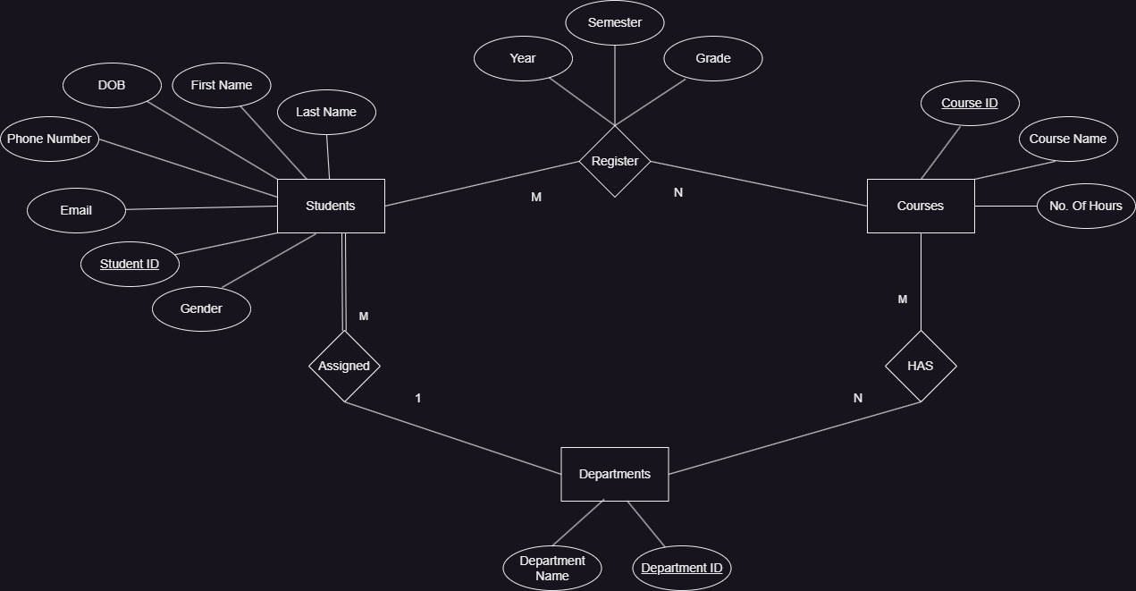

* Many students must be assigned in only one department and one department may have many students.
* Many courses may be assigned in many departments and many departments may have many courses.
* Many students may register for many courses and many courses may be registered by many students.

**Mapping:**

Students

(Student ID, First Name, Last Name, Email, DOB, Gender, Phone Number, Department ID(FK))

Departments

(Department ID, Department Name)

Courses

(Course ID, Course Name, No. Of Hours)

Departments Has Courses

(Department ID(FK), Course ID(FK))

Student Register Course

(Student ID(FK), Course ID(FK), Year, Semester, Grade)